Village of MunseyPark  1777 Northern Boulevard  Manhasset, NY 11030 | AD:______ ED:_______  Clerk Use only
(516) 365-7790
www.munseypark.org
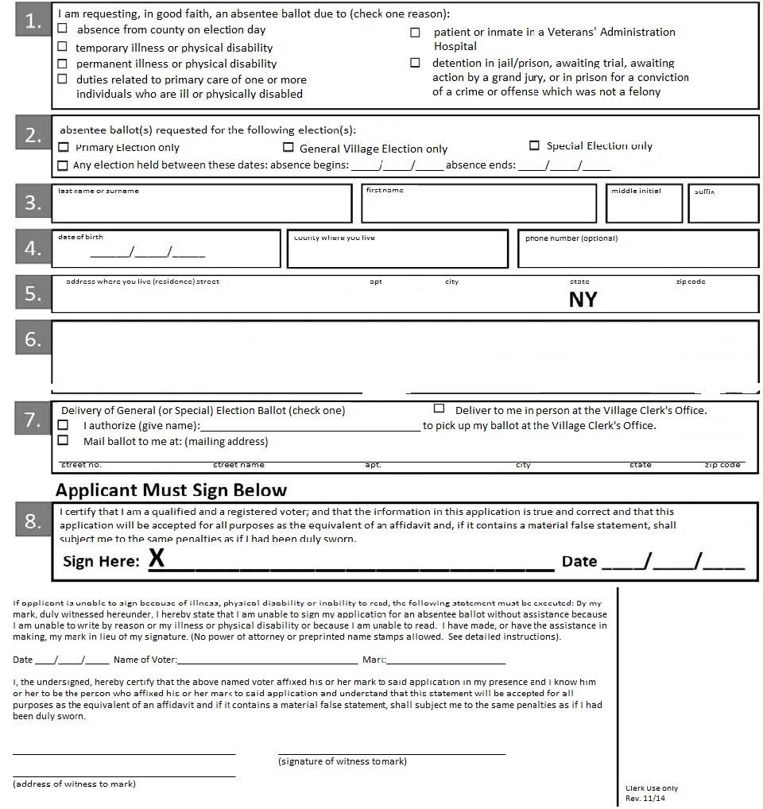
VILLAGE OF MUNSEY PARK ABSENTEE BALLOT APPLICATION
Please print clearly. See detailed instructions on back.
This application must either be personally delivered to the Village Administrator not later than the day before the election, or postmarked by a governmental postal service not later than the 7th day before Election Day. The ballot itself must be personally delivered to the Village Administrator no later than the close of polls on Election Day.
INSTRUCTIONS:
Who may apply for an absentee ballot?
Each person must apply for themselves. It is a felony to make a false statement in an application for an absentee ballot, to attempt to cast an illegal ballot, or to help anyone to cast an illegal ballot.
Where and when to return your application:
Applications must be mailed seven days before the election, or hand-delivered to your Village Administrator by the day before the election.
Options available to you if you have an illness or disability:
If you check the box indicating your illness or disability is permanent, once your application is approved you will automatically receive a ballot for each election in which you are eligible to vote, without having to apply again. You may sign the absentee ballot application yourself, or you may make your mark and have your mark witnessed in the spaces provided on the bottom of the application. Please note that a power of attorney or printed name stamp is not allowed for any voting purpose.
When your ballot will be sent:
Your absentee ballot materials will be sent to you at least 6 days before the election in which you are eligible to vote. If applicant or agent delivers the application to the Village Administrator in person after the seventh day before the village election and not later than the day before the election, the Village Administrator shall deliver such absentee ballots for those applicants who he determines are qualified to make such applications and to receive such ballots to such applicants or the agents named in the applications when such applicants or agents appear in the Village Administrator’s office.
-----------------------------------------------------------------------------------------------------------------------------------------------------------------
-----------------------------------------------------------------------------------------------------------------------------------------------------------------
RETURN TO:
Village of Munsey Park
1777 Northern Boulevard
Manhasset, NY 11030

